open terminal
cd ~
mkdir os_exp4
cd os_exp4

nano exp4_1.sh
#!/bin/bash
echo "OS Version & Release:"
lsb_release -a
echo
echo "Kernel Version:"
uname -r

Ctrl + O
Enter
Ctrl + X
chmod +x exp4_1.sh
ls
./exp4_1.sh

nano exp4_2.sh
#!/bin/bash
echo "Top 10 Processes by CPU Usage:"
ps -eo pid,ppid,cmd,%cpu --sort=-%cpu | head -11
Ctrl + O
Enter
Ctrl + X
chmod +x exp4_2.sh
ls
./exp4_2.sh

nano exp4_3.sh
#!/bin/bash
echo "Top Processes by Memory Usage:"
ps -eo pid,ppid,cmd,%mem --sort=-%mem | head -11
Ctrl + O
Enter
Ctrl + X
chmod +x exp4_3.sh
ls
./exp4_3.sh

nano exp4_4.sh
#!/bin/bash
echo "Current User:"
whoami
echo "Login Name:"
logname
Ctrl + O
Enter
Ctrl + X
chmod +x exp4_4.sh
ls
./exp4_4.sh

nano exp4_5.sh
#!/bin/bash
echo "Current Shell: $SHELL"
echo "Home Directory: $HOME"
echo "Operating System Type:"
uname
echo "Current PATH: $PATH"
echo "Current Working Directory:"
pwd
Ctrl + O
Enter
Ctrl + X
chmod +x exp4_5.sh
ls
./exp4_5.sh

Experiment No. 04
1.Display OS version, release number, kernel version
Code:
#!/bin/bash
echo "OS Version & Release:"
lsb_release -a
echo
echo "Kernel Version:"
uname -r
Press Ctrl+O
Press Enter
Press Ctril+x

OUTPUT:
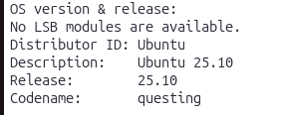
2. Display top 10 processes in descending order
Code:
#!/bin/bash
echo "Top 10 Processes by CPU Usage:"
ps -eo pid,ppid,cmd,%cpu --sort=-%cpu | head -11

OUTPUT:
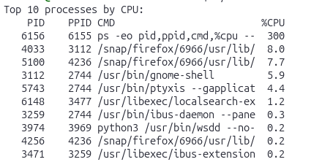

3. Display processes with highest memory usage.
Code:
#!/bin/bash
echo "Top Processes by Memory Usage:"
ps -eo pid,ppid,cmd,%mem --sort=-%mem | head -11

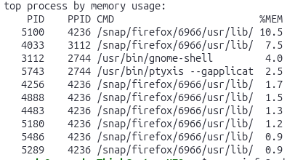OUTPUT:

4. Display current logged in user and log name.
Code:
#!/bin/bash
echo "Current User:"
Whoami
echo "Login Name:"
Logname
OUTPUT:
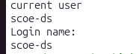

5. Display current shell, home directory, operating system type, current path setting, current working directory.
Code:
#!/bin/bash
echo "Current Shell: $SHELL"
echo "Home Directory: $HOME"
echo "Operating System Type:"
uname
echo "Current PATH: $PATH"
echo "Current Working Directory:"
pwd
OUTPUT:
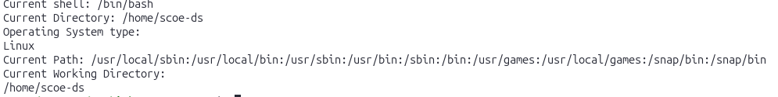

AIM
Write shell scripts to do the following:
a. Display OS version, release number, kernel version
b. Display top 10 processes in descending order
c. Display processes with highest memory usage.
d. Display current logged in user and log name.
e. Display current shell, home directory, operating
system type, current path setting, current working
directory.

RESOURCES REQUIRED
• Ubuntu Operating System
• Terminal
• Text Editor (nano)
• Sample text files

THEORY
Linux is an open-source, multi-user, multitasking
operating system widely used for servers, desktops, and
embedded systems. Ubuntu is a popular Linux
distribution that provides a powerful command-line
interface (CLI) for interacting with the system.
A shell is a command interpreter that acts as an
interface between the user and the Linux kernel. It
accepts commands from the user, interprets them, and
executes corresponding programs. The most commonly used
shell in Ubuntu is Bash (Bourne Again Shell).
A shell script is a text file containing a sequence of
Linux commands that are executed automatically. Shell
scripting helps in automating repetitive tasks,

managing system operations, and performing
administrative activities efficiently.
To create a shell script, a file with .sh extension is
created using a text editor such as nano. The first
line of the script usually contains:
#!/bin/bash
This line is called shebang, which tells the system to
use Bash shell for executing the script.
After writing the script, execution permission is given
using the chmod command. The script can then be
executed using ./filename.sh or bash filename.sh.

Conclusion:The practical was completed successfully. We
learned to write and execute shell scripts in Ubuntu
and understood basic Linux commands to display system
and user information.

